Bags 🡪 sets hvor den same tuple kan opstå flere gange

Unions på bags giver bare den ene I forlængelse af den anden

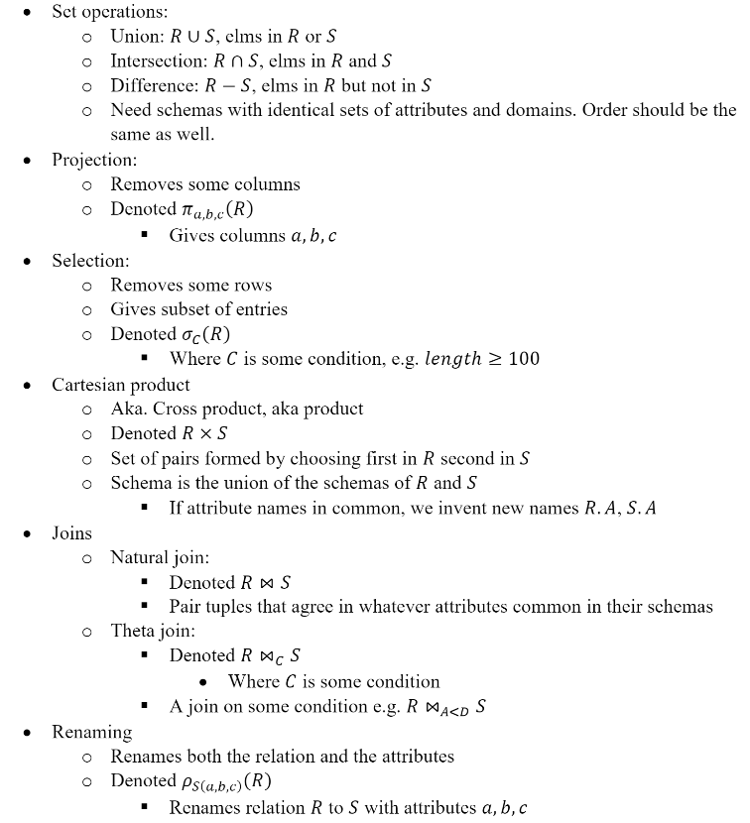

**EXERCISE 5.1.1 side 212**

Find figuren

**EXERCISE 5.1.2**

**EXERCISE 5.1.3**

**a)**

Giver den ene kolonne set nedenunder som bag. Hvis som sæt elimineres duplikationerne.



b)

join dem på class og så project til bore. Der joines hvert tuple for hver gang der er match med hvert match. Og så projectere vi til kun bore.

ships = S classes = C

1: S⋈classC  
2: πbore(1)

**EXERCISE 5.1.4**



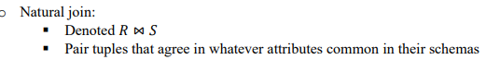

h)

vi får tuple ,t, det antal gange den mindst optræder I enten R eller S. Derefter får vi alle tuplerne fra R. Højre siden har alle tuplerne fra R og de vil derfor alle sammen matche.

i)

det samme som at give begge conditions på en gang.

**EXERCISE 5.1.5**

**a)**

Taking intersection subtracting T, same as subtracting from S and taking the intersection.  
Does not matter if we take intersection and subtract or other order.

(𝑅 ∩ 𝑆) − 𝑇 = 𝑅 ∩ (𝑆 − 𝑇)

(2 ∩ 3) − 1 = 2 ∩ (3 − 1)

2 − 1 = 2 ∩ 2

1 = 2

b)

for sets Intersection with the union same as union of the intersections

for bags If something in all relations, due to allowing duplicates it would appear once on lhs, and twice on rhs.

𝑅 ∩ (𝑆 ∪ 𝑇) = (𝑅 ∩ 𝑆) ∪ (𝑅 ∩ 𝑇)

5 ∩ (4 ∪ 4) = (5 ∩ 4) ∪ (5 ∩ 4)

5 ∩ 8 = 4 ∪ 4

5 = 8

c)

for sets just one of the conditions should hold, then in the result set. This is the same as the union due to duplicates being eliminated

for bags duplicates not being eliminated, meaning that if both conditions hold, some tuple would be once on lhs and twice on rhs.

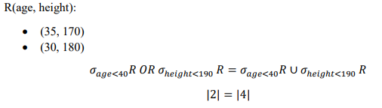

**6.1.1 page 256**

It’s not separated by a comma so B is an alias of A

**6.1.2 page 256**

a) Find the address of MGM studios.

b) Find Sandra Bullock’s birthdate.

c) Find all the stars that appeared either in a movie made in 1980 or a movie with “Love” in the title.

d) Find all executives worth at least $10,000,000. e) Find all the stars who either are male or live in Malibu (have string Malibu as a part of their address).

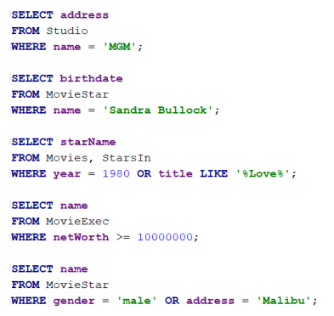

**6.1.3 page 256**

a) Find the model number, speed, and hard-disk size for all PC’s whose price is under $1000.

**SELECT** model, speed, hd   
**FROM** PC  
**WHERE** price<1000;

b) Do the same as (a), but rename the speed column gigahertz and the hd column gigabytes.

**SELECT** model, speed **AS** gigaherts, hd **AS** gigabytes  
**FROM** PC  
**WHERE** price<1000;

c) Find the manufacturers of printers.

**SELECT** maker  
**FROM** Product  
**WHERE type** = ‘printer’;

d) Find the model number, memory size, and screen size for laptops costing more than $1500.

**SELECT** model, ram, screen  
**FROM** Laptop  
**WHERE** price < 1500;

e) Find all the tuples in the Printer relation for color printers. Remember that color is a boolean-valued attribute.  
**SELECT** *  
**FROM** Printer  
**WHERE** color = **TRUE**;

f) Find the model number and hard-disk size for those PC ’s that have a speed of 3.2 and a price less than $2000

**SELECT** model, hd  
**FROM** PC  
**WHERE** speed = 3.2 **AND** price < 2000;

**6.1.5 page 258**

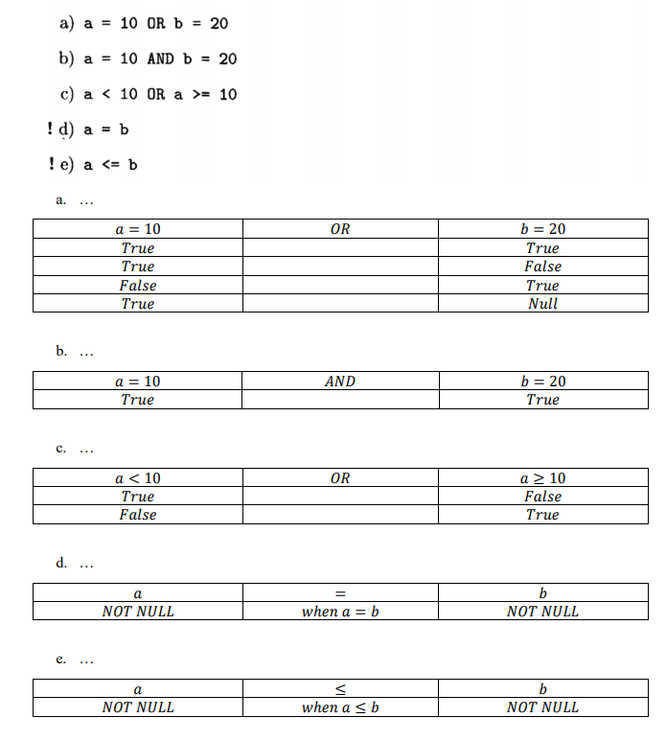

**6.2.1 page 267**

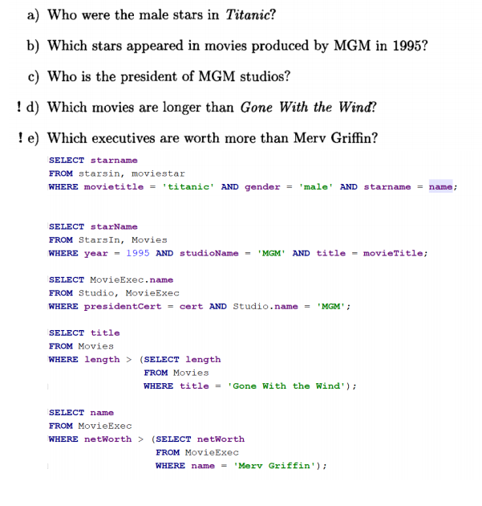

**6.2.2 page 256**

a) Give the manufacturer and speed of laptops with a hard disk of at least thirty gigabytes.

**SELECT** maker, speed  
**FROM** product, laptop  
**WHERE** product.model = laptop.model **AND** hd >= 30;

b) Find the model number and price of all products (of any type) made by manufacturer B.

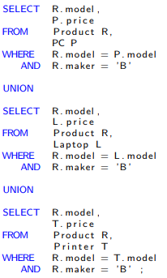

c) Find those manufacturers that sell Laptops, but not PC’s

**SELECT DISTINCT** R.maker  
**FROM** Product R  
**WHERE** R.type = 'laptop' **AND** R.maker **NOT IN**(  
 **SELECT** R.maker  
 **FROM** Product R  
 **WHERE** R.type = 'pc'  
 );

d) Find those hard-disk sizes that occur in two or more PC’s



e) Find those pairs of PC models that have both the same speed and RAM. A pair should be listed only once; e.g., list (i,j) but not (j,i).

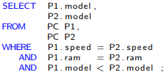

F) Find those manufacturers of at least two different computers (PC’s or laptops) with speeds of at least 3.0.

**SELECT** R. maker  
**FROM** Product R  
**WHERE** R. model **IN** (**SELECT** P.model  
 **FROM** PC P  
 **WHERE** P.speed >= 3 )  
**OR** R. model **IN** (**SELECT** L.model  
 **FROM** Laptop L  
 **WHERE** L.speed >= 3 )  
**GROUP BY** R. maker  
**HAVING** *COUNT*(R.model)>1;

**6.2.3 page 256**

a) Find the ships heavier than 35,000 tons.

SELECT S.name

FROM Ships S, Classes C

WHERE S.class = C.class AND C.displacement > 35000;

b) List the name, displacement, and number of guns of the ships engaged in the battle of Guadalcanal

SELECT S.name , C.displacement, C.numGuns

FROM Ships S , Outcomes O, Classes C

WHERE S.name = O.ship AND S.class = C.class AND O.battle = 'Guadalcanal' ;

c) List all the ships mentioned in the database. (Remember that all these ships may not appear in the Ships relation.)

SELECT name AS shipname

FROM ships

UNION

SELECT ship AS shipname

FROM outcomes;

d) find those countries that have both battleships and battlecruisers

SELECT country

FROM classes

WHERE type='battleship'

INTERSECT

SELECT country

FROM classes

WHERE type='battlecruiser';